Task for: Sunday, February 5, 2023

1. According to task 4-2-2023, add search engine as the bellow:

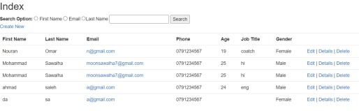

1. Add 2 columns for image, and for CV

In all CRUD (operations)